Motor Sizing Software

User Manual - Delta

2023-04-17

Topra World Pte Ltd

8 Eu Tong Sen Street

#14-94

The Central

Singapore 059818

**IMIT (Pvt) Ltd**

**No 82, Galle Road , Colombo 04, Sri Lanka**

**Phone: (+94)719927926 Fax: (+94)115926926**

**Web :www.imit.lk Contact: info@imit.lk**

Contents

Motor Sizing Software 1

A Proposal To: PBA System 1

2021-01-14 1

Summary 3

Motor Sizer 3

Master Data Synchronizer 3

Product prospective/Objective 4

Technology Upgrade 4

Improved Architecture 4

Entity diagram 4

Improved Usability 5

Budget and Payment term 5

Budget 5

Payment term 5

Deliverables and timeline 6

Deliverables 6

Limitation 6

Timeline 6

Accountabilities 6

Topra 6

PBA System 6

# Changes to Masters

#### Motor Category

New Field added to the motor category to recognize actuator motor categories.

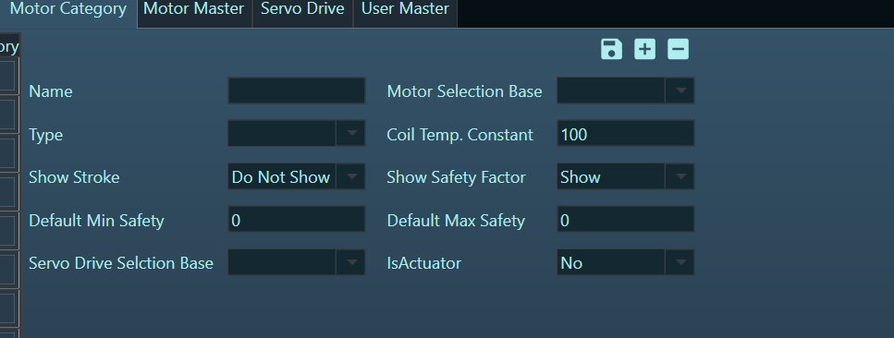

#### Motor Master

Two new parameters added to the motor master

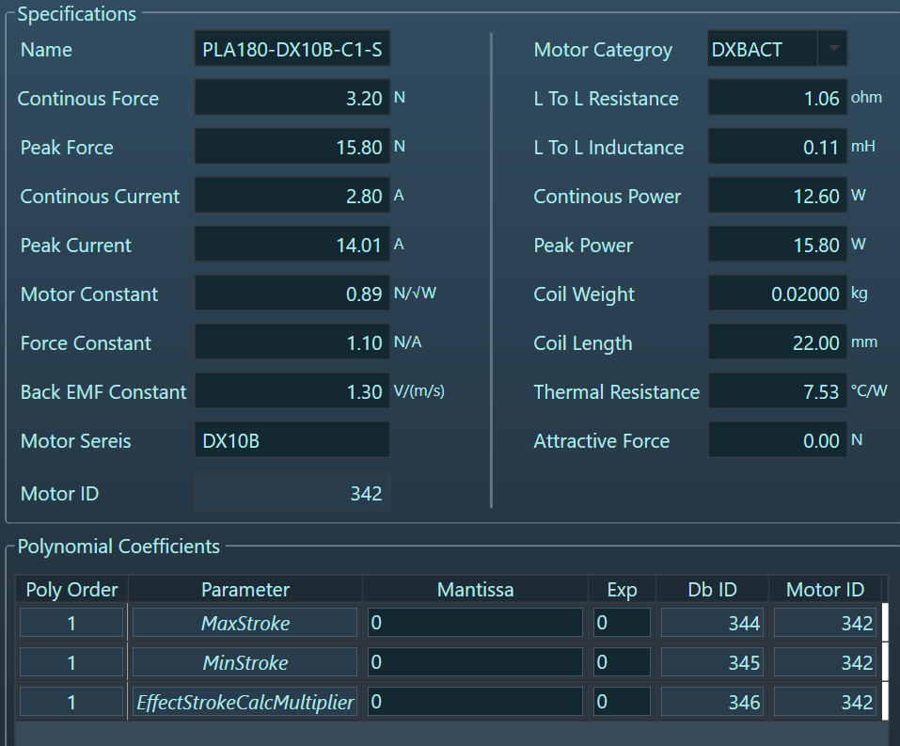

|  |  |
| --- | --- |
| Parameter | Usage |
| MaxStroke | This uses to validate the maximum values for maximum distance in an axist |
| MinStroke | This uses to validate the minimum values for maximum distance in an axist distance for an axist |
| EffectStrokeMultuplier | Use to cacullate effective stroke to determine multiplier based on the maximum distance. (84) |

#### Motor Sizer

Motor Sizer will have a new button call actuator .

Once the actuator button is pressed it will opne a popup to enter actuator related details.

Once the actuator information is set , new field will appear to set the maximum distance, which will be used to calucalte the effective stroke.

